Volunteer with Union Settlement
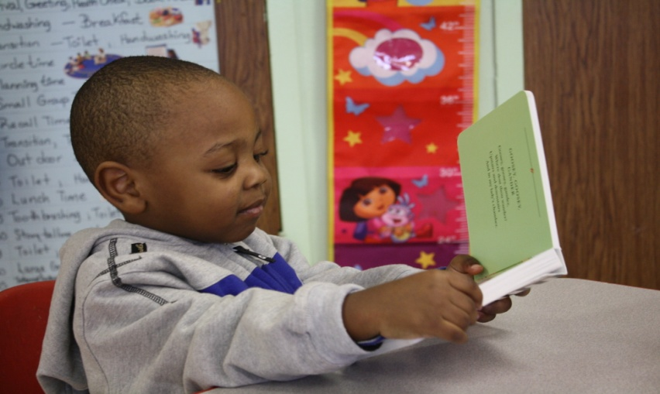
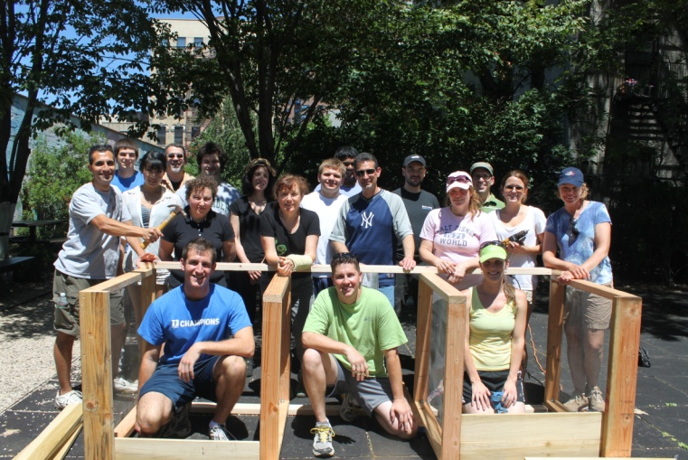
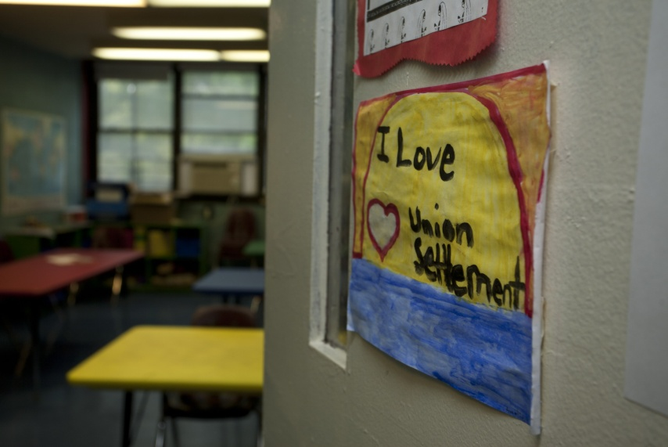
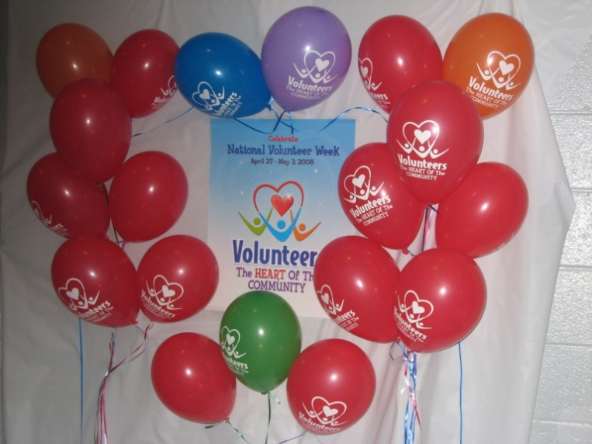
A Complete List of all Group and Individual Volunteer Opportunities for 2014
Interested volunteers should contact
Catherine McGahan
Development Associate - Donor Relations & Volunteers
646-672-5082
cmcgahan@unionsettlement.org
Volunteer as a Group:
Fall Harvest Festival-Celebrate fall with our afterschool program by hosting a number of activities around the theme of fall in our community garden. Students can create crafts with leaves, color fall themed designs, build a scarecrow for the garden, and any number of other fall themed activities. This event will take place after school from 3:30-6:30 any day of the week. Groups between 15-25 volunteers are preferable.
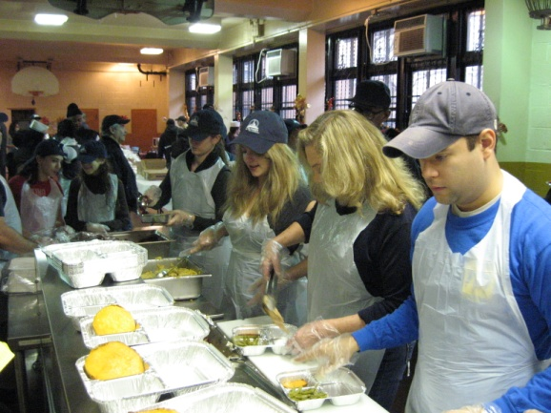
Meals on Wheels-Help pack and deliver meals to hundreds of seniors in the East Harlem community. Volunteers pack the food then separate into teams to deliver meals to seniors either on foot or in our transport vans. Many of our seniors are homebound and live alone, so volunteers provide them with a warm meal and give them someone to talk to. Meals are delivered Monday-Saturday, 9:00am-12:30pm. Weather emergencies provide a special challenge and are a great opportunity to help.
Holiday Gift Drive-Hold a toy drive at your office; place of worship, or just among friends. Every year we collect thousands of gifts for children ages 2-13 and senior citizens. We rely entirely on support from volunteers and corporations to make the yearly gift drive possible. Boxes should be displayed in early November. Gifts will be picked up by December 17-18th.
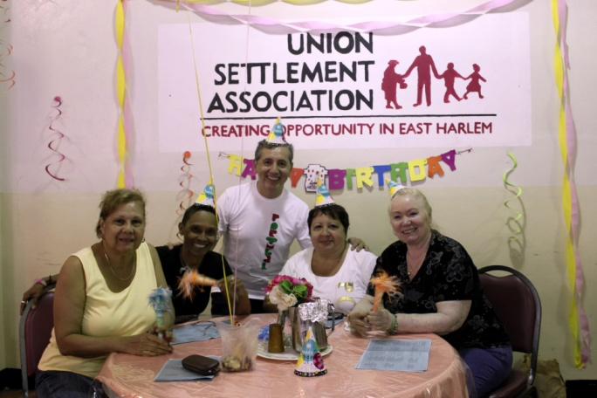
Gift Wrapping Party-Help us wrap the thousands of gifts we get donated. We ask volunteers to come to Union Settlement at 237 East 104th Street in groups for social “wrapping parties.” The wrapping party will be on December 19th starting at noon and running into the evening.
Host a Holiday Party-Each of our preschools, senior centers, and after school programs holds its own holiday celebration (totaling anywhere from 9-14 holiday parties a year), so we need a lot of extra hands! Help decorate a center and enjoy festive activities with guests. Parties usually occur right before the holidays. Any size group is welcome, although we prefer groups of 5-20 volunteers.

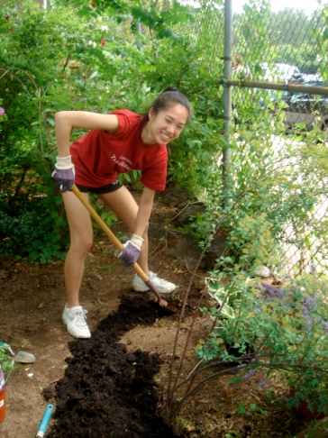
Gardening-Spring and summer is gardening season and we have a lot to accomplish! Lend a hand with planting, weeding, painting and building in our large community garden, El Sitio Feliz located at 237 E 104th Street or with a group of seniors at one of the smaller Senior Center Gardens at various locations in East Harlem. Gardening can take place any day, morning or afternoon. Any size group between 3-40 volunteers is welcome.
Summer Camp Olympics-Work with us to create a “mini-Olympics” for our 200 Summer Day Camp participants, ages 6-12. Volunteers will organize the children into groups and lead them through a variety of activities inside our gym and community room. Scheduling is flexible over the summer months. Any size group between 15 to 40 volunteers is welcome.
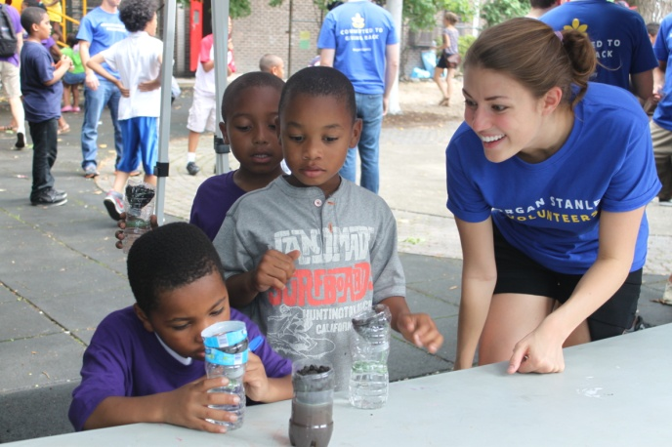
Garden Themed Party- Volunteers can host a party in our community garden that focuses on the theme of environmental education. This event can include 10-25 preschool children ages 2-5 or older students ages 6-12 in our afterschool programs. Volunteers would assist students in participating in activities like planting a seed to take home, a cooking demo or taste test, or an environmental art project- like painting garden signs from reused materials. This event would take place between 3:30pm-6pm on a weekday. Groups between 5-40 volunteers are welcome. You can also help with a Senior Garden Party - arrive early to help with decorating and set-up, help serve food, dance and party with the seniors and stay to help staff clean up. Groups between 3-7 volunteers are welcome.
Young Father’s Day BBQ-Each year we work with 85 non-custodial fathers to offer parenting workshops, job counseling, and professional development. Join them and their children for an early Father’s Days BBQ during an afternoon in June. Volunteers are needed to set up and staff the party, as well as to spend some time with the fathers and kids. Great volunteer opportunity for fathers!
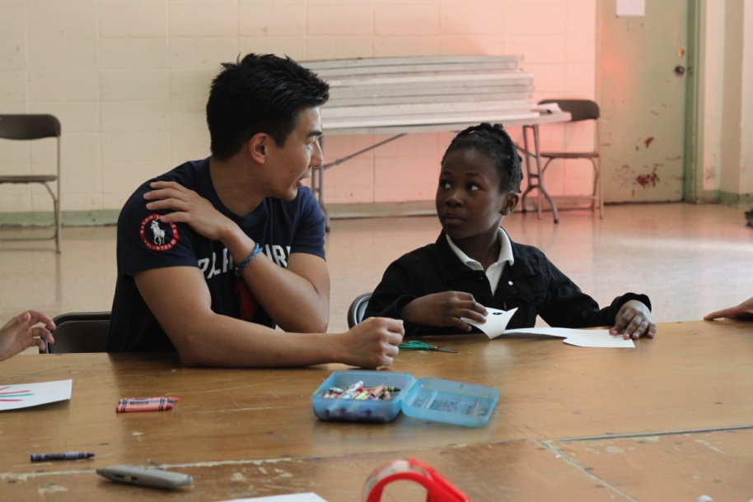
Volunteer as an Individual:
Homework Helper in Youth-Assist children ages 5-12 with their homework in our afterschool program located at our Washington Community Center, 1775 Third Avenue (at 98th Street). The program runs from 4:00pm-5:30pm. Volunteers are given curriculum and help with general subjects such as Math and Reading.
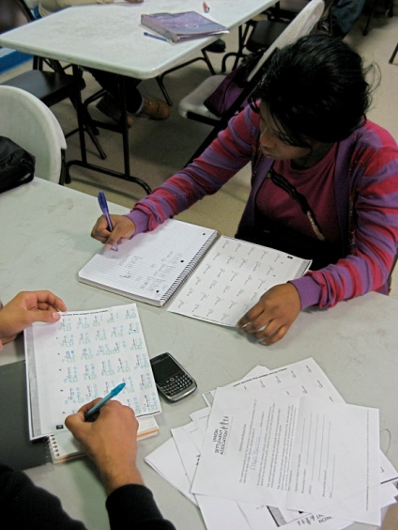
GED Teaching Assistant-Volunteers will prepare Adult Education students in East Harlem to take the High School Equivalent (formerly GED) exam by teaching history, science, reading comprehension, writing and/or grammar. Volunteers will work alongside a full-time staff teacher teaching a class of 25 students. Curriculum and materials will be provided 5 days in advance so that assistants can familiarize themselves with the materials to be taught. Classes take place at 237 E 104th St, New York, NY Volunteers. Classes are held Monday-Thursday 9:00am-11:30am. Volunteers are encouraged to commit to individual trimesters, with the entire school year running from September 16, 2013 to June 19, 2014.

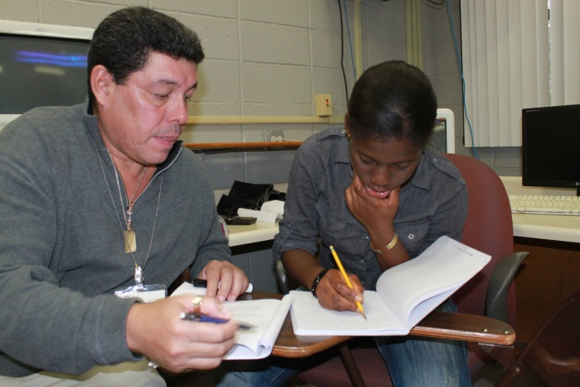
Literacy Partners-Improve the overall English fluency of Union Settlement Adult Education students, with a particular focus on literacy. Strong English skills are required, and being bi-lingual is a plus. Volunteers will work one-on-one or with a small group to cover provided curriculum. Classes take place at 237 E 104th St, New York, NY. Volunteers serve at least one shift per week on Tuesdays and Fridays, 10:00am-12:00pm September 16th- December 19th.

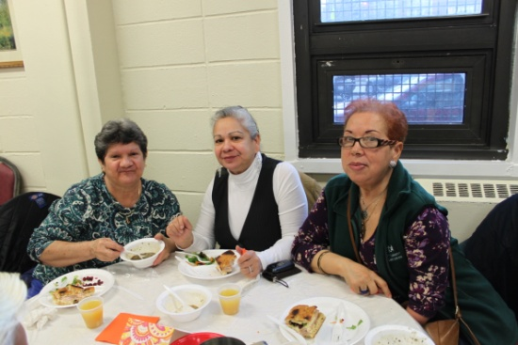
Senior Activity Specialist-Help develop and implement exercise or recreational activities, such as dance, knitting, gardening, and art, for senior participants in Union Settlement’s programs. Volunteers will assist in the creation of educational materials for senior activities and motivate seniors. The activities are held in the morning on weekdays and the commitment is at the discretion of the volunteer.
Friendly Visiting-Visit Seniors in their homes for an hour each week. During that time volunteers can chat, read aloud, go for a walk, play board games, and assist with light errands. Volunteers should commit to 3-4 hours per month for 3-6 months.
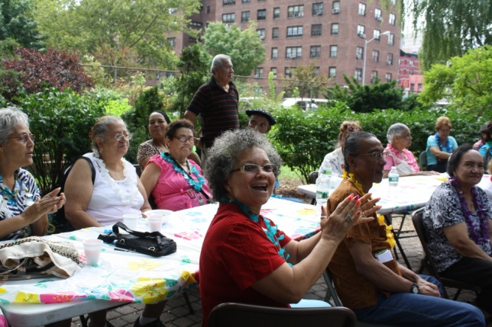
Senior Chats-Volunteers can call a Senior to check on them and have a friendly conversation. Volunteers should commit to 2-4 hours per month for 3-6 months. This activity is great because it can take place anywhere.

Beautification & Maintenance Volunteer-Help improve the appearance of our centers by gardening, painting or cleaning.

Administrative Assistant-Volunteers will help with filing and data entry in any of our locations. Commitment is between 2-5 hours per week.

